



**Douglas-fir Decline Complex in Southwest Oregon: Estimating Susceptibility and Loss at Multiple Scales**

SWORIDSC-X-X Laura Lowrey, Max Bennett, and Bill Schaupp

April 2025

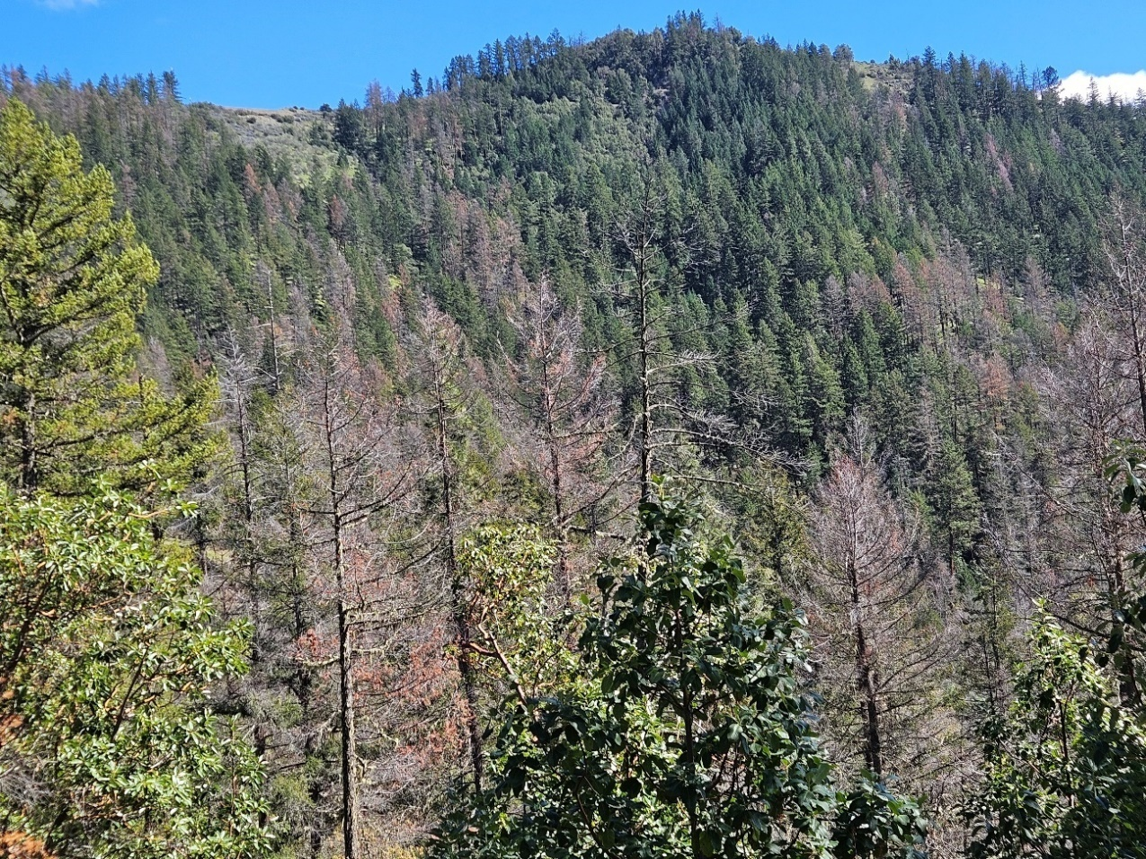

DF mortality in Woodrat Recreation Area, Medford BLM District, April 2024

**Douglas-fir Decline Complex in Southwest Oregon:**

**Estimating Susceptibility and Loss at Multiple Scales**

Laura Lowrey1, Max Bennett2, Bill Schaupp3

**EXECUTIVE SUMMARY**

The recent increase in Douglas-fir (*Pseudotsuga menziesii*) decline and mortality in southwest (SW) Oregon, known as the Douglas-fir Decline Complex (DFDC), results from harsh site conditions and persistence of hot droughts. In any given stand affected by the decline complex there is typically a mix of dead, dying, and green trees showing varying levels of vigor. This document describes a rating system to help landowners assess and prioritize management across landscapes and sites affected by DFDC, susceptibility to the problem, and to estimate probable near-term losses. Specifically, this rating system estimates the probability of decline and mortality expected over a 5-year period at the landscape and site scales and over a 3-year period at the individual tree scale, on moisture-stressed sites in the Klamath, western Cascade, and coastal mountains. This rating system is best used as a nested approach across management scales. In general, 5-year landscape susceptibility is highest on hot, dry sites in and around the interior Rogue, Applegate, and Umpqua valleys. Climatic Water Deficit (CWD) and mean annual precipitation are used to categorize landscapes as high, moderate, and low risk. Site susceptibility refers to the probability of finding mortality and the expected mortality over the next 5 years at an individual site, based on proximity to beetle populations, topography, proximity to stand edges, and presence/absence of moisture-limited soils, all based upon influence of these factors on the biology of the tree or flatheaded fir borer. The individual tree rating refers to the probability that a particular Douglas-fir (DF) tree will die from DFDC within the next three years and is intended to be useful in developing marking guidelines. This rating uses the site rating plus an individual tree crown decline rating. Managers can expect to see a much higher percentage of DF die-off following years that are hotter than normal.

*1Forest Entomologist, USDA Forest Service, Forest Health Protection, Southwest Oregon Forest Insect*

*and Disease Service Center, Central Point, OR*

*2Forester, Retired Emeritus Faculty, Oregon State University,*

*3Forest Entomologist, Retired, USDA Forest Service*

**INTRODUCTION**

The term “DF decline complex (DFDC)” refers to the decline and mortality of Douglas-fir (DF) due to infestation from the flatheaded fir borer (FFB) (*Phaenops drummondi*), frequently in conjunction with other secondary insects and disease, as well as abiotic damage such as injury to tree vascular tissues. The decline complex has been described as a decline spiral resulting from harsh site conditions and persistent episodes of hotter drought (Bennett and Adlam 2023, ODF 2016, Flowers and Kanaskie 2007).

In any given stand affected by the decline complex there is typically a mix of dead, dying, and green trees showing varying levels of vigor. Landowners and managers need a tool to predict if and when individual Douglas-fir trees in such stands are likely to die as well as estimate the probability and amount of Douglas-fir mortality at the site and landscape scales.

**OBJECTIVE: To help land managers prioritize management areas for treatment related to dead and dying Douglas-fir across the expanse of interior SW Oregon, we have developed a preliminary rating system to predict the probability of infestation and estimate basal area lost to mortality in Douglas-fir, based upon field observations, data from field plots and photo monitoring, and recent research findings.**

**DFDC SUSCEPTIBILITY AND LOSS RATING SYSTEM**

We created a nested rating system including landscape, site, and individual tree susceptibility and estimate of loss ratings. We define susceptibility as the likelihood of decline and mortality at any given scale and estimate of loss as the amount of decline and mortality to expect (i.e., percent of trees, basal area, etc.). The rating system is preliminary and is being updated as we accumulate more field data. Methods and data sources used in developing the rating system are described in Appendix B.

This rating system focuses on the probability of DF mortality associated with the DF decline complex on moisture-limited, low to moderate elevations sites in SW Oregon. This is essentially the Oregon portion of the Klamath Mountains ecoregion but also includes portions of the western Cascades and Coast range ecoregions (figure 1 – I think this should be an Ecoregion map showing these three ecoregions due to wording). Figure 1 (and then this should be figure 2) demonstrates the severity and extent of trees per acre killed cumulatively from 2015-2024 as recorded by USFS Aerial Detection Survey (ADS), excluding years 2020-2021 when no survey was flown. The departure from normal levels of DF mortality and the mechanism for this recent uptick in DF mortality scope and scale has been described extensively (Bennett et. al 2023, Bennett and Adlam 2023, ODF 2016, Flowers and Kanaskie 2007).

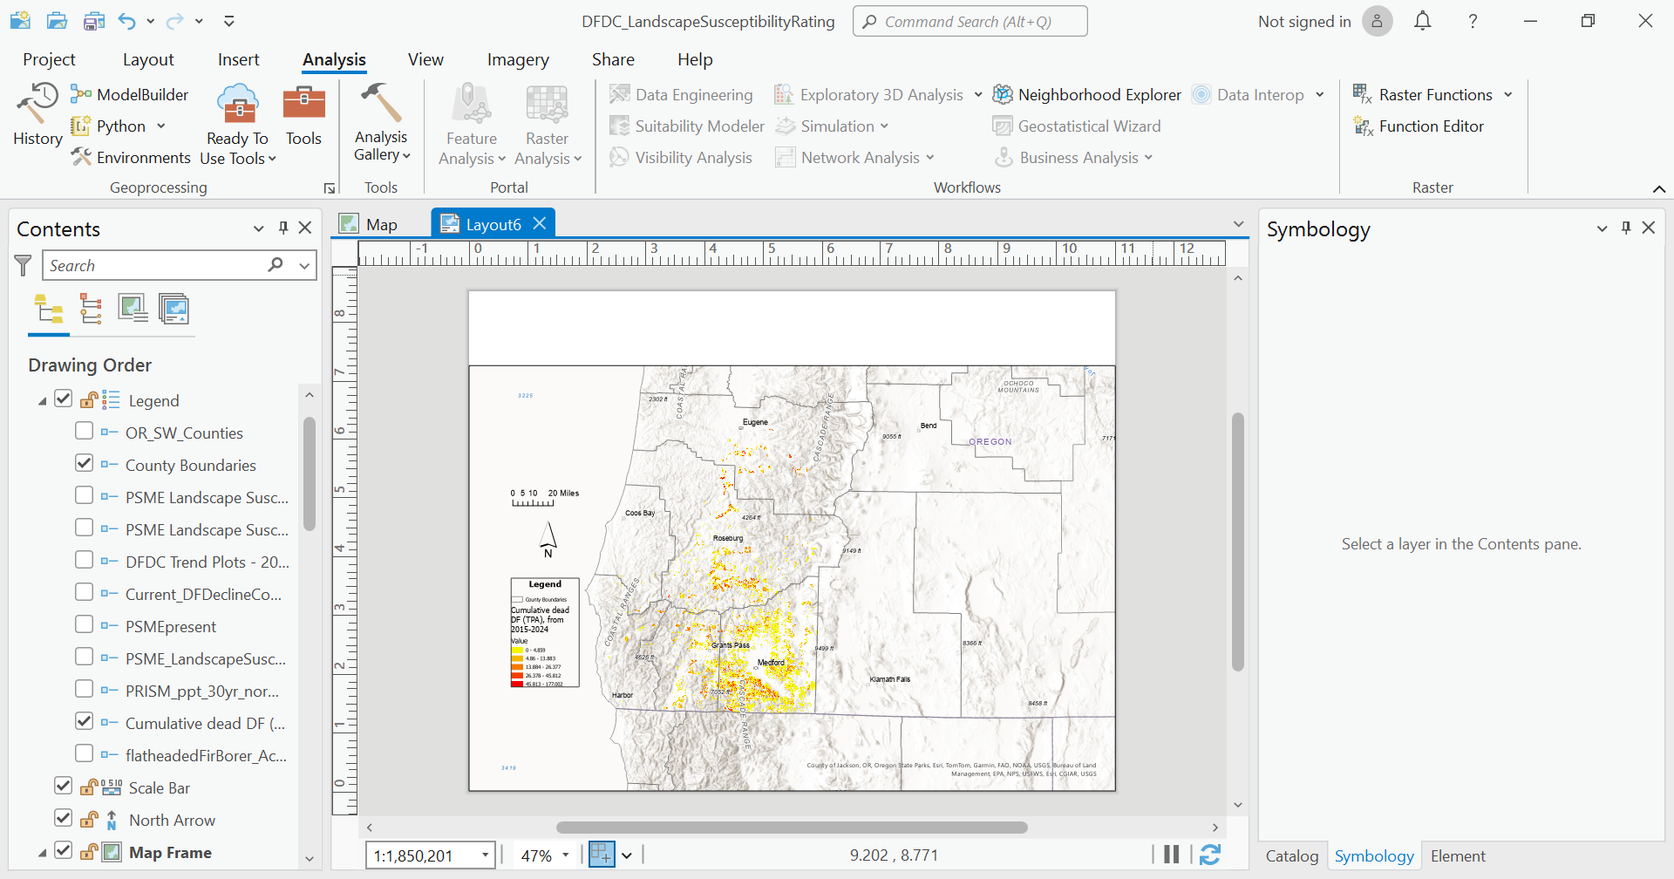

Figure 1 (maybe 2 if you add an Ecoregion map) . Aerial Detection Survey data showing cumulative trees per acre of DF mortality attributed to flatheaded fir borer fro 2015-2024. Updated version using GNN data from 2014 and a Douglas-fir proportion of total basal area from 2021. The DFDC rating system was based on datasets in these counties of the Klamath Mountains, western Cascades, and Coast Range ecoregions of southwest Oregon.

No formal susceptibility or projection of loss rating for the flatheaded fir borer or the DFDC exists to date and the following rating system has worked reasonably well during initial testing on the Rogue River-Siskiyou National Forest and Medford BLM lands. This nested rating framework indicates decline and mortality expected over a 5-year period at the landscape and site scales and over a 3-year period at the individual tree level. For each scale, ratings are categorized as high, moderate, and low. The higher the rating, the greater the potential effect on DF decline. As a result, this rating system may be used as a prioritization tool.

This rating system does not address many other potential causes of Douglas-fir mortality, such as the Douglas-fir beetle (*Dendroctonus pseudotsugae*) or root disease, and is untested outside the geographic area described above. It is most appropriate for use in moisture-limited sites in SW Oregon where the DF decline complex is thought to be responsible for much of the recently observed DF mortality. This rating system can be applied to other areas by adjusting some of the metric options to fit those areas after consulting local forest health experts.

***Landscape Susceptibility Rating.*** The landscape susceptibility rating encompasses the likelihood of encountering Douglas-fir decline and mortality in the next 5 years at the watershed or landscape scale, the abundance and severity of mortality, and the probability that mortality will increase in that area (table 1).In general, 5-year susceptibility is highest on hot, dry sites in and around the interior Rogue, Applegate, and Umpqua valleys. On a broad geographic scale, increased susceptibility correlates well with reduced average annual precipitation (figure 2). Susceptibility is also associated with climatic water deficit (CWD), a measure of moisture stress that integrates precipitation, temperature, and soil water storage; the deficit is the potential minus actual evapotranspiration (figure 3). Researchers have used CWD to model the current and future distribution of tree species, moisture stress, and susceptibility to insects. The spatial resolution of the CWD data is a 90m grid.

Field observation and ADS data suggest that the majority of mortality in Jackson County has occurred below 3,500’ elevation, but DFDC-related mortality has been detected across the elevational range of Douglas-fir in this area. Roughly equivalent elevation thresholds in Josephine and Douglas County are 2,500’ and 2,000’, respectively. As the climate continues to warm, and as more lower elevation DF are killed, large-scale mortality will likely occur at progressively higher elevations.

These estimates are based on DF decline and mortality levels observed over the past 5 years, a period that was both hotter and drier than “normal” (defined as the 1990-2020 averages). Decline and mortality toward the higher ends of the ranges shown are likely if conditions remain hotter and drier than normal or if they become even more extreme. Conversely, decline and mortality closer to the lower ends of the ranges shown are likely if hotter drought conditions ease significantly over the next few years.

**Table 1**. Douglas-fir Decline Complex landscape susceptibility and loss rating.

|  |  |  |  |
| --- | --- | --- | --- |
| **Susceptibility rating** | **Mean annual precip. / Mean annual CWD** | **3-5 year probability of mortality** | **3-5 year estimated DF BA loss** |
| **Very high**  DF mortality very abundant & intensifying | <35” AND  >250mm | >75% | 15%-80%+ |
| **High**  DF mortality abundant & intensifying | <35” OR  >250mm | 50%-75% | 10%-50% |
| **Moderate**  DF decline & mortality common during events, especially on harsh sites (e.g., margins of oak woodlands) | 35”-45” AND/OR  200mm-250mm | 25%-50% | 5%-35% |
| **Low**  DF decline complex is uncommon but can occur at low levels in association with harsh site conditions | >45” AND/OR  <200mm | <25% | 0%-25% |

Mean annual precipitation identifies DF mortality susceptibility at broad spatial scales. CWD takes into account topographic and soil factors in addition to climate and is available at a finer spatial resolution (90m grid cells), making it useful for site-specific adjustments in evaluating landscape susceptibility. For example, consider a site with less than 35" mean annual precipitation that is located on a steep, northeasterly aspect at 3,500 ft elevation, with a CWD of less than 200mm. In this case it could be appropriate to base the landscape susceptibility rating more on CWD than on precipitation. However, small areas of favorable topography and lower CWD may be surrounded by a much hotter, drier landscape with high beetle population pressure, resulting in high susceptibility despite the relatively low CWD.

Conversely, sites with high CWD are sometimes found in high precipitation zones. This could occur, for example, on a steep, southwesterly aspect with shallow, rocky soils in an area with more than 60" average annual precipitation. Here, even though the landscape susceptibility rating based on precipitation alone would be low, a higher rating based on the CWD may be appropriate.

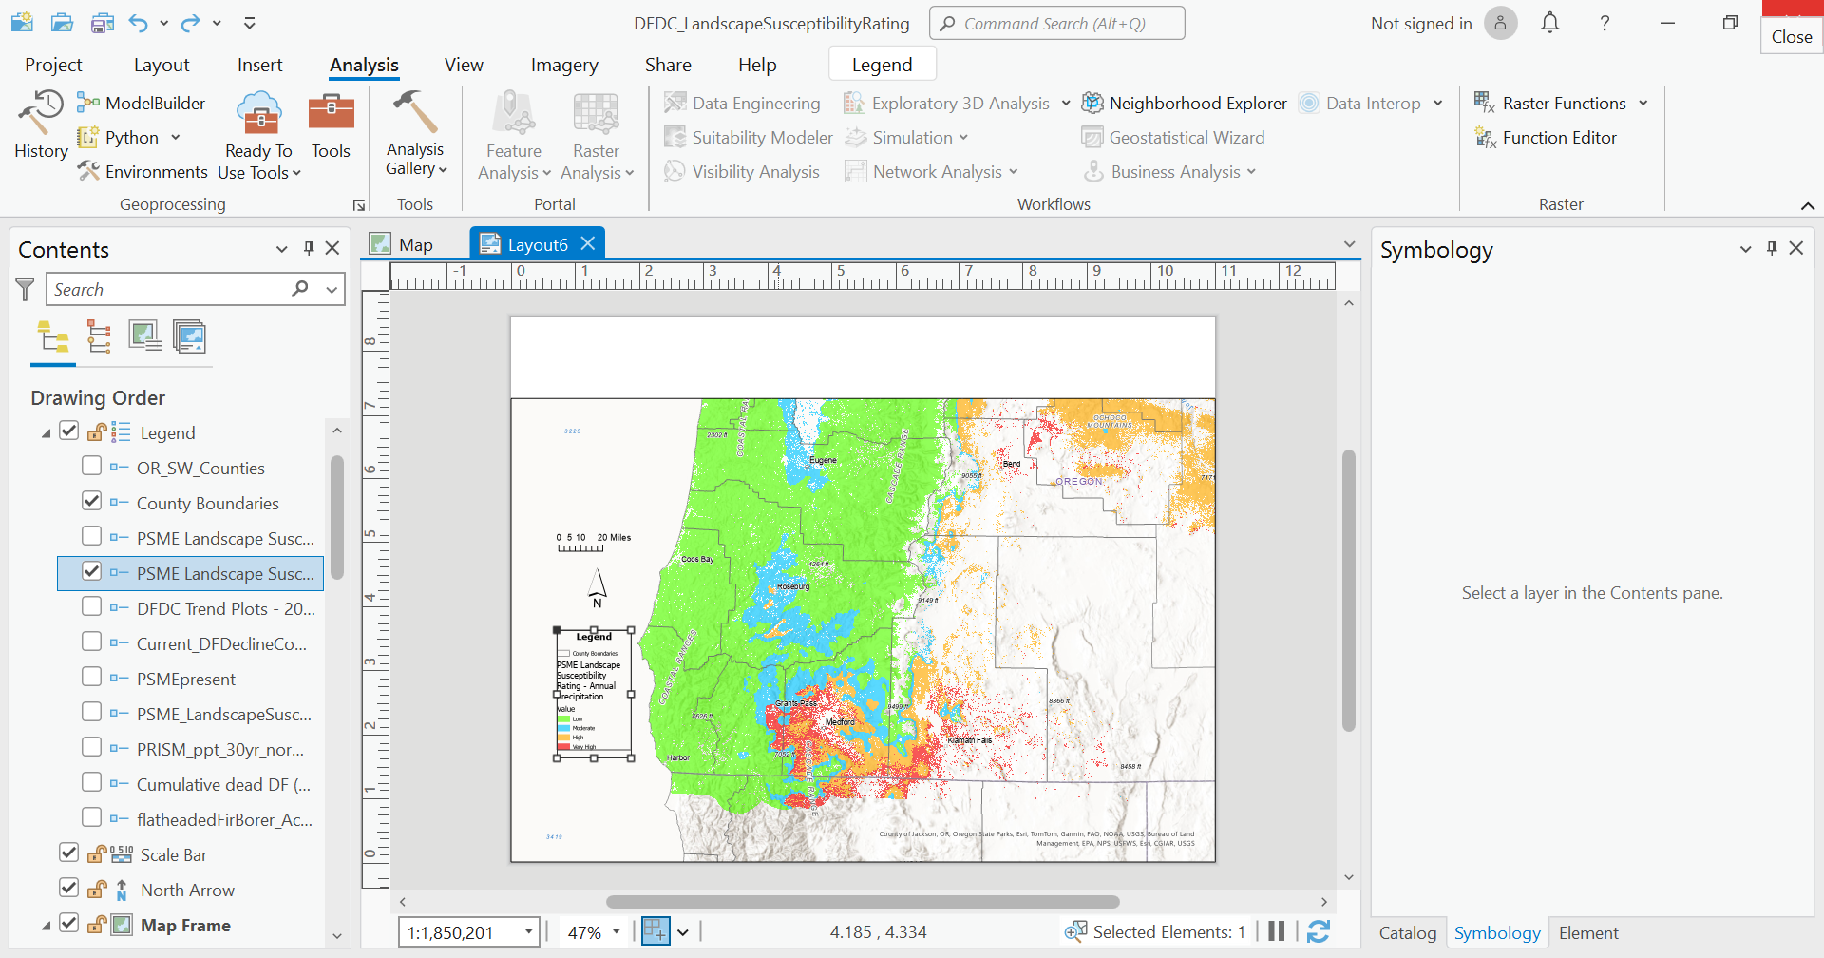

Figure 2. Landscape susceptibility to DFDC based on Prism data of annual precipitation. Dataset extent is only for Oregon and where Douglas-fir is likely to occur (based on LEMMA GNN modeled basal area). Classes are: 1 (Low): >60 inches; 2 (Moderate): 35.01-60 inches, 3 (High): <=35 inches; 4 (Very High) where the CWD rating is high and where the separate rating system based on annual precipitation is also high. (by color: red=very high, orange=high, blue=moderate, green=low).

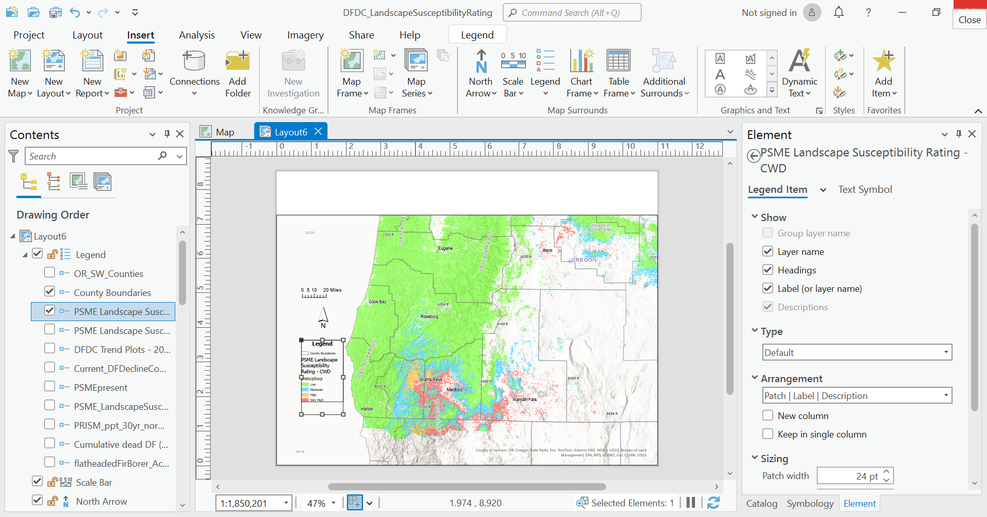

**Figure 3.** Landscape susceptibility to DFDC based on the reference period (1981-2010) of mean total climatic water deficit (CWD). Dataset extent is only for Oregon and where Douglas-fir is likely to occur (based on LEMMA GNN modeled basal area). Classes are: 1 (Low): < 200mm; 2 (Moderate): 200-249.9 mm; 3 (High): >= 250mm; 4 (Very High) where the CWD rating is high and where the separate rating system based on annual precipitation is also high. (by color: red=very high, orange=high, blue=moderate, green=low).

***Site-Scale Susceptibility Rating.*** Site-scale susceptibility refers to the probability of finding mortality, and the expected mortality, over the next 5 years at an individual site, defined as a one-acre area surrounding a given point on the landscape. Data from multiple sites can be used to assess stand-level susceptibility. Key elements of the rating are proximity to beetle populations and stand and physiographic characteristics, all based upon influence of these factors on the biology of the tree or flatheaded fir borer. Beetle population pressure refers to presence of green-infested trees that have “woodpecker activity” along the stem (see appendix A, figure 4), or recently dead trees with red crowns1 found either within a one-acre plot around the site (high population levels) or within ¼ mile of the site (moderate population levels). Topographic factor refers to heat load at the site that adds to moisture stress for the trees, with southwest aspects especially moisture stressed and NE aspects not. Proximity to edge refers to the access flatheaded fir borers have to their preferred hosts, trees with canopies in the sunlight, and to their tendency for limited flight dispersal. Soil factor refers to moisture stress experienced by the tree because of the poor water holding capacity of some soils. We have found proximity to Oregon white oak (*Quercus garryana*) to be a proxy for droughty soils. Each metric gets a score, as well as a total site score, that relates to the probability of finding DF decline and predicts basal area loss at the site over the next 5 years. We use a scale of 0 to 10 for simplicity, with 0 meaning low susceptibility and 10 meaning high susceptibility to DFDC.

Determining if a recently killed tree was infested by the FFB without the actual life stages present with a high degree of certainty can be difficult, as there are many possible causes of mortality aside from the FFB. Signs and symptoms indicating that the dead tree was infested with FFB include:

* Red-brown foliage, as opposed to bright red that is associated with the Douglas-fir beetle (appendix A, figures 1-3). Trees lacking red foliage (e.g., have gray foliage or all foliage has dropped off the tree) likely died one or more years previously and no longer contribute to local FFB populations.
* Woodpecker activity (appendix A, figure 4). Not all trees killed by the FFB will have obvious woodpecker shaving and excavation.
* Presence of large FFB larvae in the bark, as no other buprestid in DF is present at later stage just under the bark. Additionally, removing bark to examine beetle galleries could be helpful, but at this stage it is difficult to distinguish FFB galleries from those of other flatheaded borers. Galleries begin as wide as a pencil line and broaden out for a few inches as visible as consumed phloem. (appendix A, figure 5). Galleries in standing green trees do not etch the wood.
* Pitch jewels (appendix A, figure 6) indicate FFB infestation and should be confirmed in the bark crevices of at least one tree at the site. Pitch jewels do not necessarily indicate that the FFB will successfully develop.
* Black phloem (appendix A, figure 7) indicates infestation and development of FFB within the tree and that the tree will likely die. To check for this, chop through the bark into the phloem, preferably under a pitch jewel.

Field observation indicates that trees less than about 12” DBH are seldom infested with the FFB, although it does happen. DF mortality associated with the FFB seems to be most common in mature trees ranging from 60-150 years in age. FFB-related mortality in younger DF is much less common. Whether this is due to size or age-related differences in tree vigor, or some other factor, is unknown.   There may also be an association with the taller trees.

FFB-related mortality also tends to occur in “hot spots,” spatially aggregated locations of mortality that range from a clump of a few trees to patches many acres in size. We assume this is due, at least in part, to localized buildups of beetle populations. Because it can be difficult to predict when these buildups will occur, estimating the 3–5-year probability of mortality and amount of loss in any given location can be challenging.

Context should also be considered. Is the dead tree with red foliage located in an area with other verified FFB mortality? Is mortality abundant? Is the site located in a high-risk landscape? If the answer to these questions is yes, then the likelihood that the tree in question was infested by the FFB is high.

**Table 2.** Douglas-fir Decline Complex site susceptibility and loss rating. Work conducted in 2023 and 2024 across SW Oregon federal lands of Jackson, Josephine, Douglas, Lane, Coos and Curry Counties (Figure 1, Appendix B).

|  |  |  |
| --- | --- | --- |
| **Site Susceptibility Rating** | | |
| **Factor** | | **Points** |
| **Local beetle population pressure** | | |
| DF mortality from FFB found within 1-acre plot (120’ radius) | | 6 |
| DF mortality from FFB found within ¼ mile | | 3 |
| DF mortality from FFB not found within ¼ mile | | 0 |
|  | | |
| **Topographic factor (heat load)** | | |
| Southerly aspects, typically southwest, frequently in combination with one or more of the following: >35% slopes, ridges & upper slope positions, convex terrain | | 2 |
| All others | | 1 |
| NE aspects, typically in combination with concave terrain | | 0 |
|  | | |
| **Proximity to stand edge** | | |
| Stand edge is within 100’ of site | | 1 |
| Stand interior | | 0 |
|  | | |
| **Soil factor** | | |
| Soil moisture availability is severely limited due to shallow depth, high clay content, and/or other factors. The presence of Oregon white oak is often an indicator of these conditions. | | 1 |
| All others | | 0 |
|  | | |
| **Susceptibility Category and Loss Prediction** | **Total Points** | |
| ***High*** –   * Significant DF mortality (10-100% of trees) is likely to occur within 3-5 years; recent DF mortality is often present; * ≥10% of individual DF in high sites classified as high for the individual tree rating, meaning they have >50% probability of mortality within 3 years; * ~20% of these sites have recent DF mortality with ≥ 30% of DF basal area recently killed | | ≥ 6 |
| ***Moderate –***  Some DF mortality may occur within 3-5 years; recent mortality may be present | | 4-5 |
| ***Low –***  DF mortality is unlikely to occur within 5 years | | 0-3 |

Plant association and potential natural vegetation (PNV moisture level)

Decline and mortality are more likely to be encountered and will tend to be more severe on plant associations classified as dry. These include, but are not limited to, the following associations:

* Oregon white oak series

Oregon white oak-Douglas-fir/poison oak

* Ponderosa pine series

Ponderosa pine-California black oak

Ponderosa pine-Douglas-fir

* Douglas-fir series

Douglas-fir-ponderosa pine/poison oak

Douglas-fir/dry shrub

Common indicator species for dry sites include poison oak (*Toxicodendron diversilobum*), hairy honeysuckle (*Lonicera hispidula*), whiteleaf manzanita (*Arctostaphylos viscida*), wedgeleaf ceanothus (*Ceanothus* cuneatus), and whipplevine (*Whipplea modesta*).

**Individual Tree Susceptibility Rating** This rating refers to the probability that a particular DF tree will die from DF Decline Complex within the next three years. This rating is intended to be a rapid assessment useful in developing marking guidelines. This rating uses the site rating plus a crown decline rating. The crown decline rating represents recent decline, within the last five years or so. Symptoms associated with recent crown decline include, but are not limited to, loss of needles from the branch tips, giving a “claw” appearance, red and yellow branchlets scattered throughout the crown that are likely a sign of cavitation, and transparency where much sunlight is visible through the tree crown.

**Table 3.** Douglas-fir Decline Complex individual tree susceptibility rating. Work conducted in 2023 and 2024 across SW Oregon federal lands of Jackson, Josephine, Douglas, Lane, Coos and Curry Counties (Figure 1, Appendix B).

|  |  |  |
| --- | --- | --- |
| **Individual Tree Susceptibility Rating** | | |
| **Factor** | | **Points** |
| **Site susceptibility rating** (see Site Susceptibility Rating) | | 0-10 |
|  | | |
| **Crown decline rating** | | |
| Severe recent crown decline | | 3 |
| Moderate recent crown decline | | 2 |
| Light recent crown decline | | 1 |
| No recent crown decline | | 0 |
|  | | |
| **Total points** | | 0-13 |
|  | | |
| **Category and Interpretation and Estimate of Loss** | **Number of Points** | |
| ***High risk*** (>50% probability of mortality in 3 years) | | 11-13 |
| ***Moderate risk*** (10-50% probability of mortality in 3 years) | | 8-10 |
| ***Low risk*** (<10% probability of mortality in 3 years) | | 0-7 |

*Note: DF mortality estimates in these ratings refers specifically to mortality associated with the DF decline complex, not mortality from all possible causes.

**ADJUSTING THE RATING SYSTEM BASED ON WEATHER**

Managers should expect more mortality in the year following a growing season that is significantly hotter and/or drier than normal and this is true across all scales. Following a period of hot drought, mortality is likely to be at the higher end of the ranges provided as the estimates of loss in table 1. There could be a higher percentage of sites and trees within sites rated as high following one or more harsh years. The biological explanation is that tree growth may cease following an extreme heat wave (temperatures over 104F) or a period of chronically elevated temperatures (days over 90F), allowing the FFB to complete its development and kill the tree. In these conditions, beetle populations can escalate rapidly.

**MANAGEMENT STRATEGIES TO ADDRESS THIS ISSUE**

climate-adapted density reduction (e.g., OSU’s goldilocks tables) and gene flow by way of introducing other provenances based on climate models (e.g., SST)?

**ACKNOWLEDGEMENTS**

This work was performed by a collaborative group of USFS-FHP, Ecology, Biometrician, seasonal crews, and Medford BLM Silviculture and Fire Ecology as part of Program of Work duties. We thank Bill Kuhn, Devin McMahon, Patricia Hochhalter (USFS Ecologists), Josh Bronson (Plant Pathologist), Lisa Meredith (BLM Silviculturist), Jena Volpe (BLM Fire Ecologist) for insightful and helpful discussion about this monitoring effort. We thank Karin Wolken and Luis Lopez-Contreras (Biometricians) for initial stand stratification, planning, and data summary assistance. We thank Bill Kuhn for help with the figures. We thank crew members Andrea Agnasanti, Angela Ma, Zoey Boisen, Sarah Williamson, Leah Gelfand, Megan Sides, Bianca Jussen, Devin McMahon, Pat Hochhalter, and Josh Bronson for help with arduous data collection. We thank Zoey Boisen and Angela Ma for assistance with data entry. Data are freely available from the USDA Forest Service, please contact L. Lowrey (laura.lowrey@usda.gov).

**RESOURCES:**

**Atzet, T., D. E. White, L.A. McCrimmon, P.A. Martinez, P.R. Fong, and V.D. Randall. 1996. Field guide to the forested plant associations of southwestern Oregon. USDA Forest Service, Pacific Northwest Region, Technical Paper R6-NR-ECOL-TP-17-96.**

**Bennett, Max, Shaw, David C., Lowrey, Laura. 2023. Recent Douglas-fir Mortality in the Klamath Mountains Ecoregion of Oregon: Evidence for a Decline Spiral. Journal of Forestry fvad007,**[**https://doi.org/10.1093/jofore/fvad007 07 March 2023**](https://doi.org/10.1093/jofore/fvad007 07%20March%202023)**.**

**Bennett, Max and Chris Adlam, OSU Extension Service. 2023.**[**Trees on the Edge: Understanding Douglas-fir Decline and Mortality in Southwestern Oregon.**](https://extension.oregonstate.edu/catalog/pub/em-9406-trees-edge)**OSU Extension Service Manual 9406.**

Oregon Department of Forestry. 2016. Flatheaded Fir Borer. Forest Health Fact Sheet. 2 pgs.Blogs.oregonstate.edu/dfmortality.

Flowers, R. and Kanaskie, A. 2007. Flatheaded Fir Borer (*Phaenops drummondi*). Oregon Department of Forestry. Forest Health Note. 2 pgs.

**Appendix A. Photos Illustrating Signs and Symptoms of DFDC**

**Crown Decline**

**Table X.** Symptoms used to observe crown decline associated with DFDC. Transparency, branch dieback and red and yellow branchlets have been repeatably observed across 2023-2024 FHP trend plots, and crown color and appearance can be helpful, as well. This is a sliding scale that is subjective and requires judgement.

|  |  |
| --- | --- |
| **Crown Decline Category** | **Elements** |
| Low | * Transparency - little to none, foliage dense * Branch tip dieback “claw” - recent dieback observed for one to a few of the branches along the outer crown edges * Red and yellow branchlets - observed at very light levels throughout the crown * Crown color- foliage dark green * Crown appearance- well balanced growth form |
| Moderate | * Transparency - increasing throughout some of the crown * Branch dieback “claw” - abundantly observed for many branches along the crown edges * Red and yellow branchlets - discoloring abundantly visible all over the crown * Crown color - may be dark green or yellow-green discoloring * Crown appearance - some overall shrinking appearance, drooping of branches, needles shorter |
| High | * Transparency - abundant throughout the crown * Branch dieback “claw” - abundantly observed for many branches along the crown edges * Red and yellow branchlets - abundantly visible all over the crown * Crown color- usually yellow-green * Crown appearance- overall shrinking appearance, drooping of branches, needles shorter |

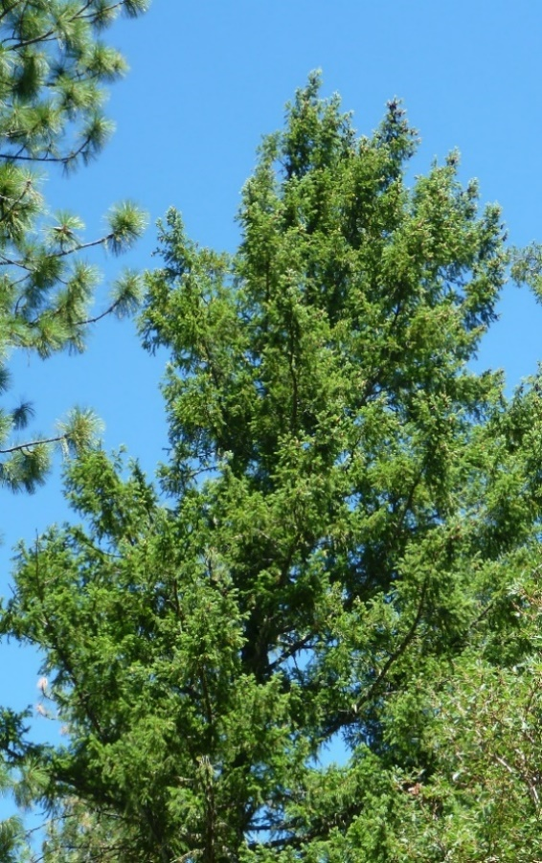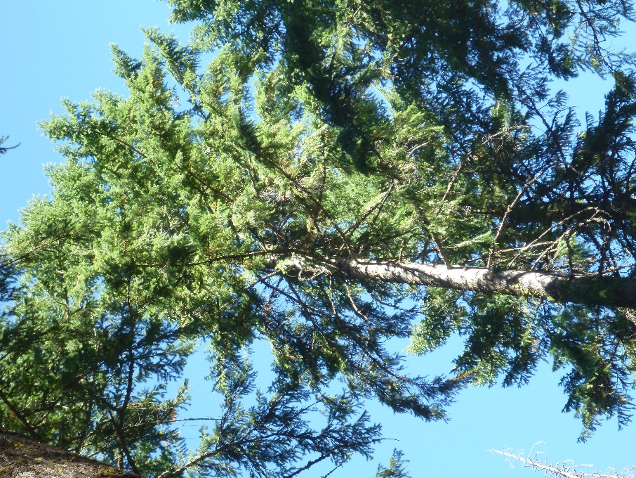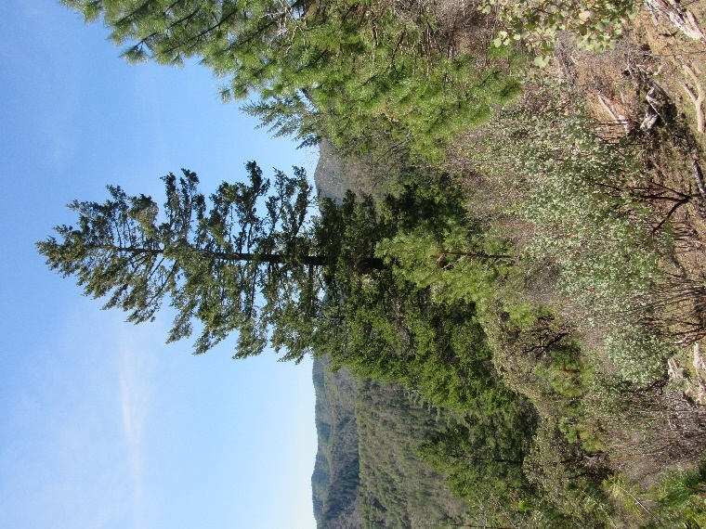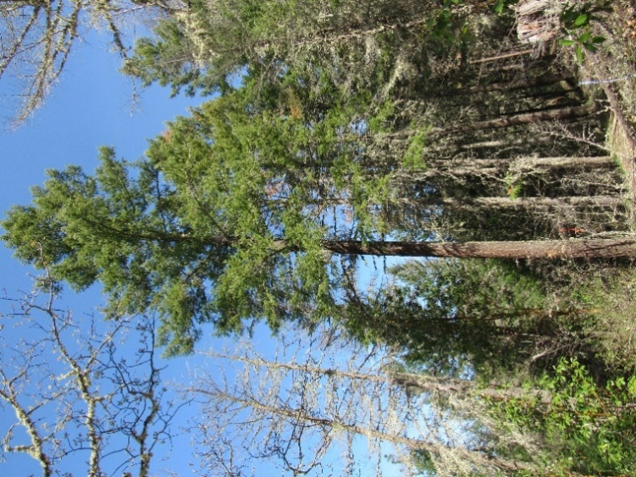

**Figure 1. Low Crown Decline.** DF crowns showing low crown decline symptoms. Most of the foliage is dark green with little transparency, and/or red and yellow branchlet discoloring can be observed at very light levels throughout the crown, and/or recent branch dieback ("claw") observed for one to a few of the branches along the crown outline. Arrows: red=claw; yellow=transparency; blue=red, and yellow branchlets.

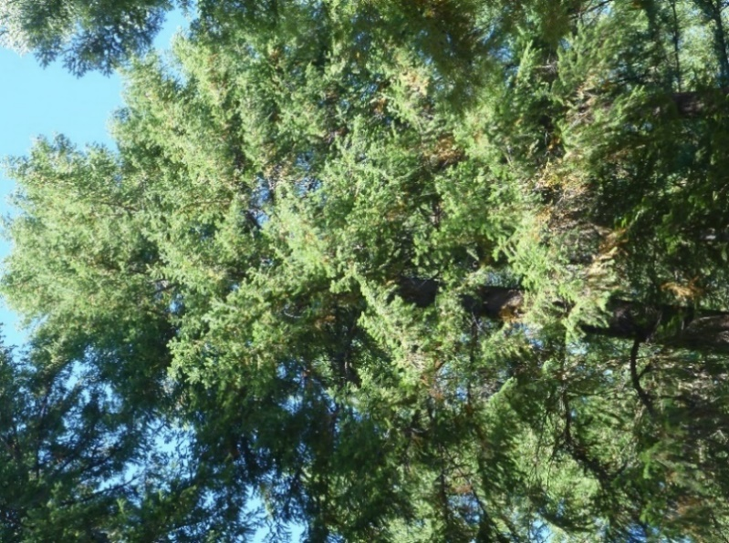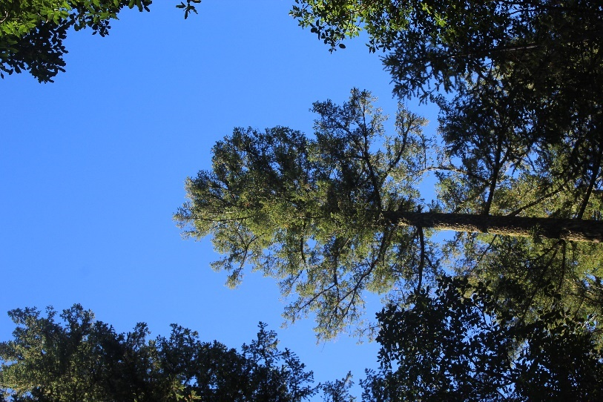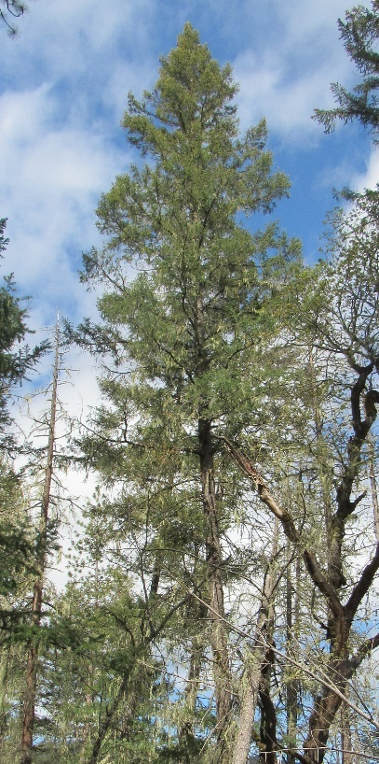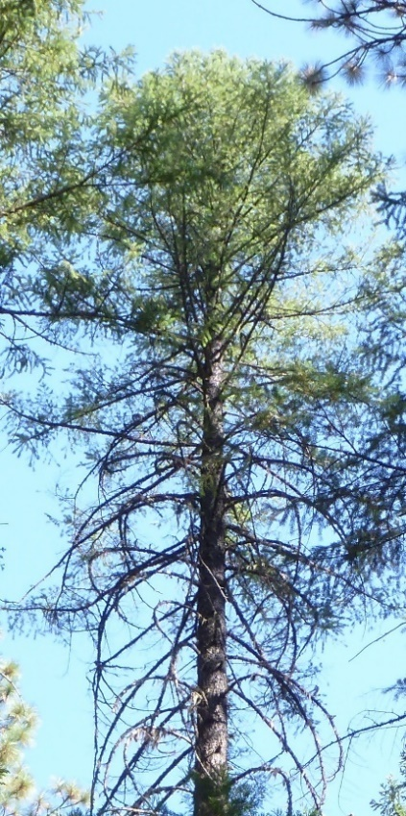

**Figure 2. Moderate Crown Decline.** DF crowns showing moderate crown decline symptoms. Foliage may be dark green or yellow- green, with transparency increasing, and red and yellow branchlet discoloring visible at light to moderate levels throughout crown, and/or recent branch dieback (“claws”) observed along some of the crown outline. Arrows: red = claw, yellow = transparency, blue = red and yellow branchlets.

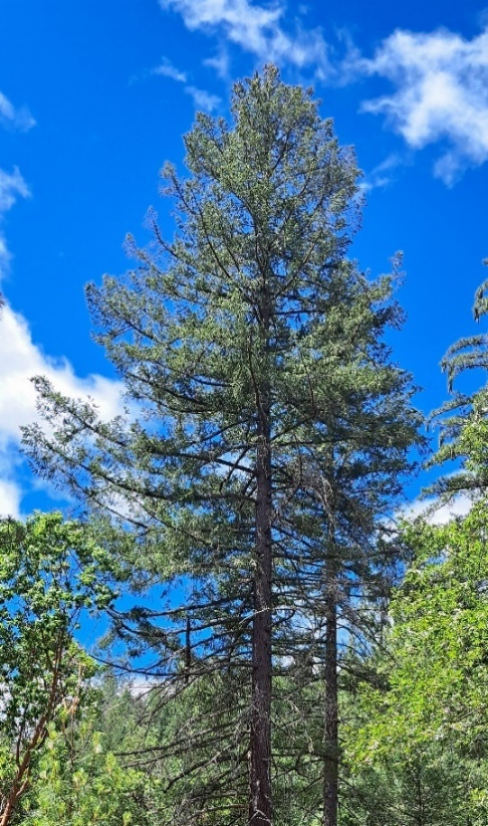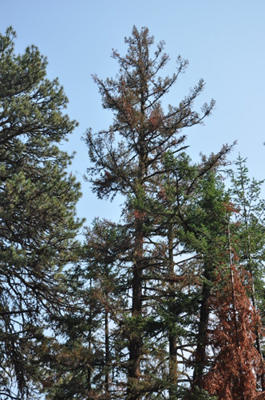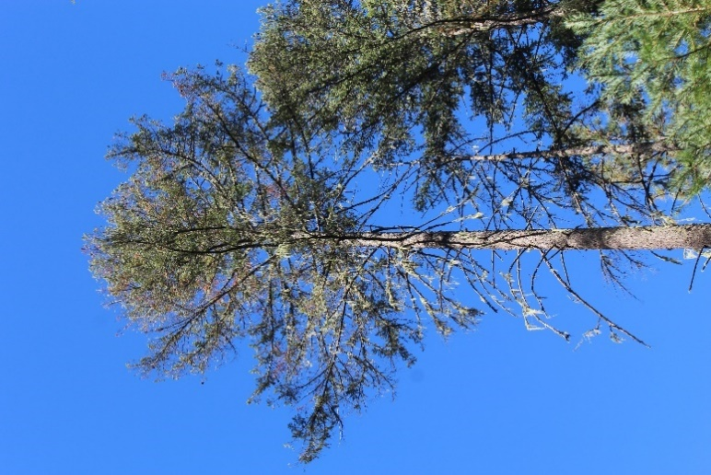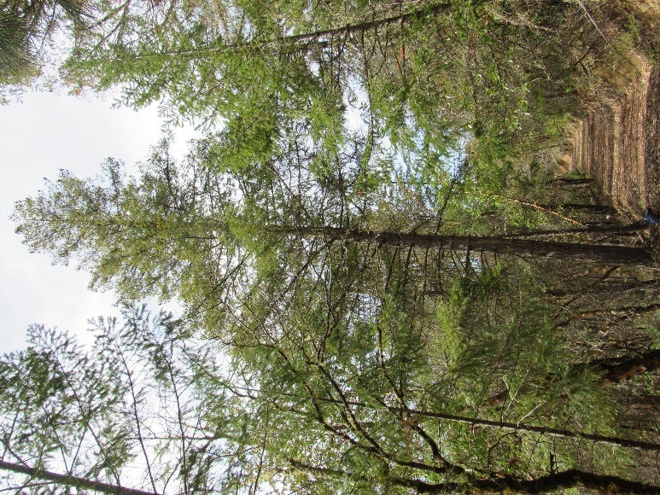

**Figure 3. High Crown Decline.** DF crowns showing high crown decline symptoms. Foliage usually yellow-green, with abundant transparency, red and yellow branchlet discoloring abundantly visible all over the crown, and recent branch dieback ("claw") abundantly observed for many branches along the crown outline. Arrows: red=claw; yellow=transparency; blue=red and yellow branchlets.

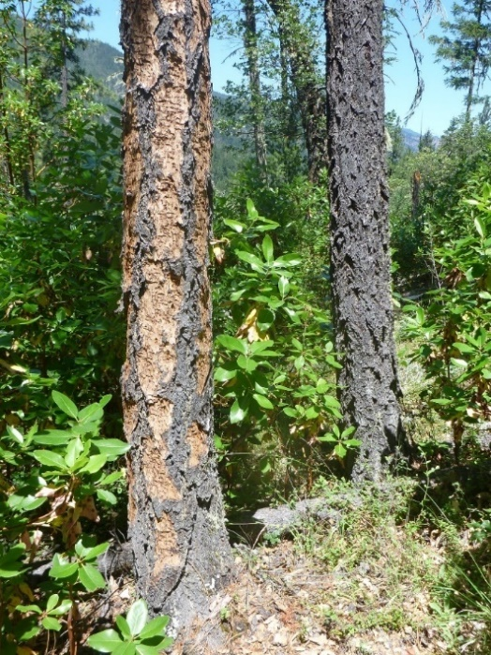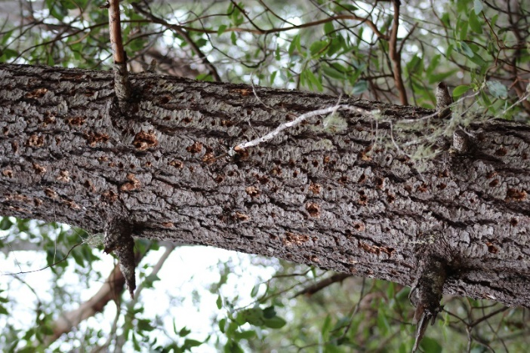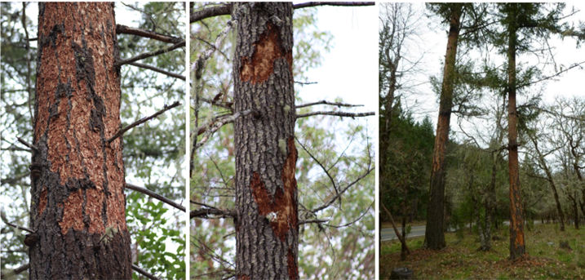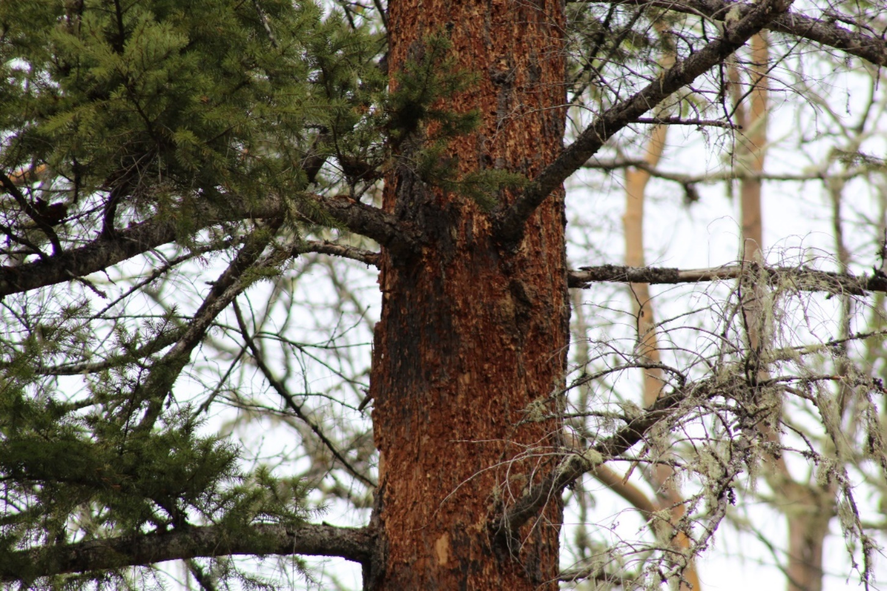

**Figure 4.** Woodpecker activity is a sign of the FFB and indicates almost certain death of the tree within 3 years. Woodpecker activity can be observed as light shaving across the entire stem of the tree, in smaller sections, or deeper hole excavations.

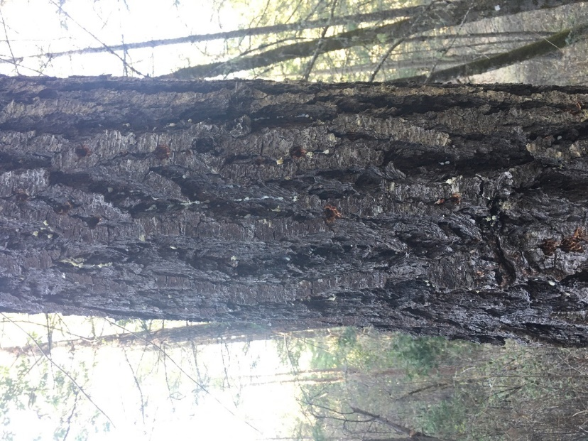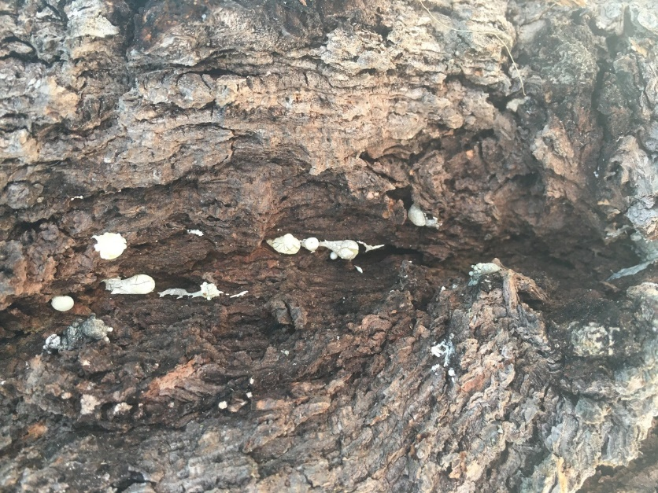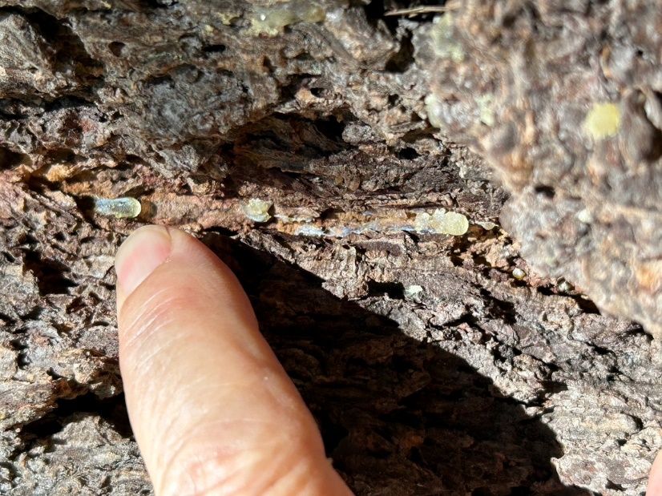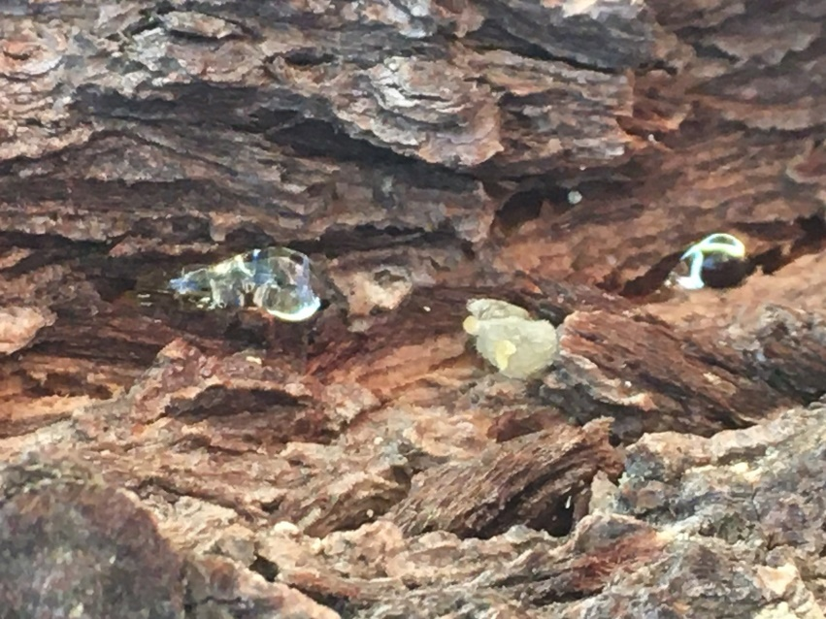

**Figure 5.** **Pitch jewels** indicate FFB infestation and come out of bark crevices (upper left), look like clear balls of sap (upper right), begin to drip and harden (lower left), and then turn white or light yellow (lower right).

**FFB Larvae and Galleries**

1. b.)

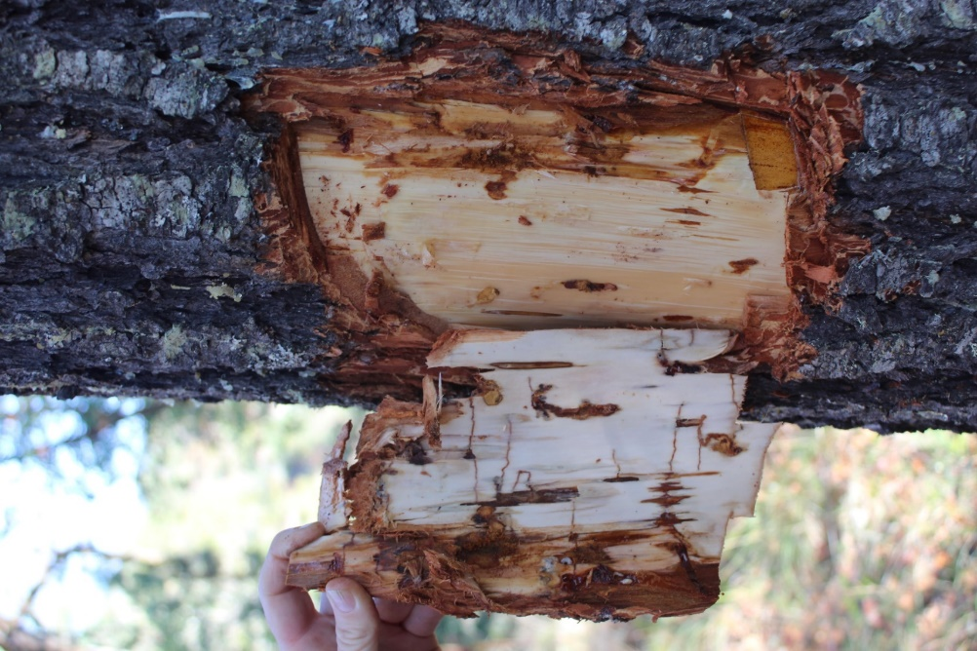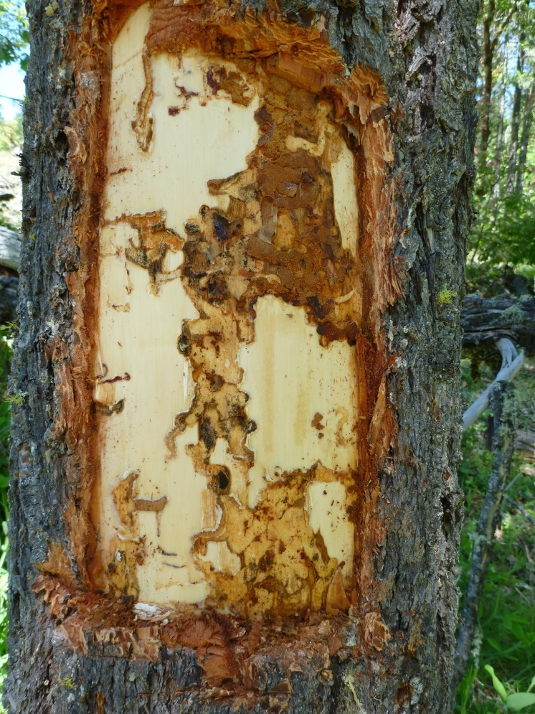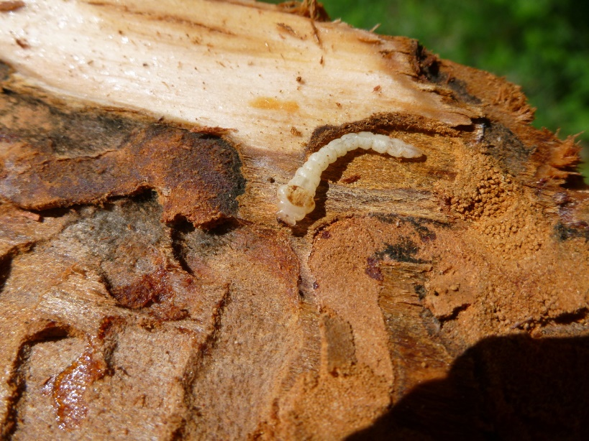

c.)

d.)

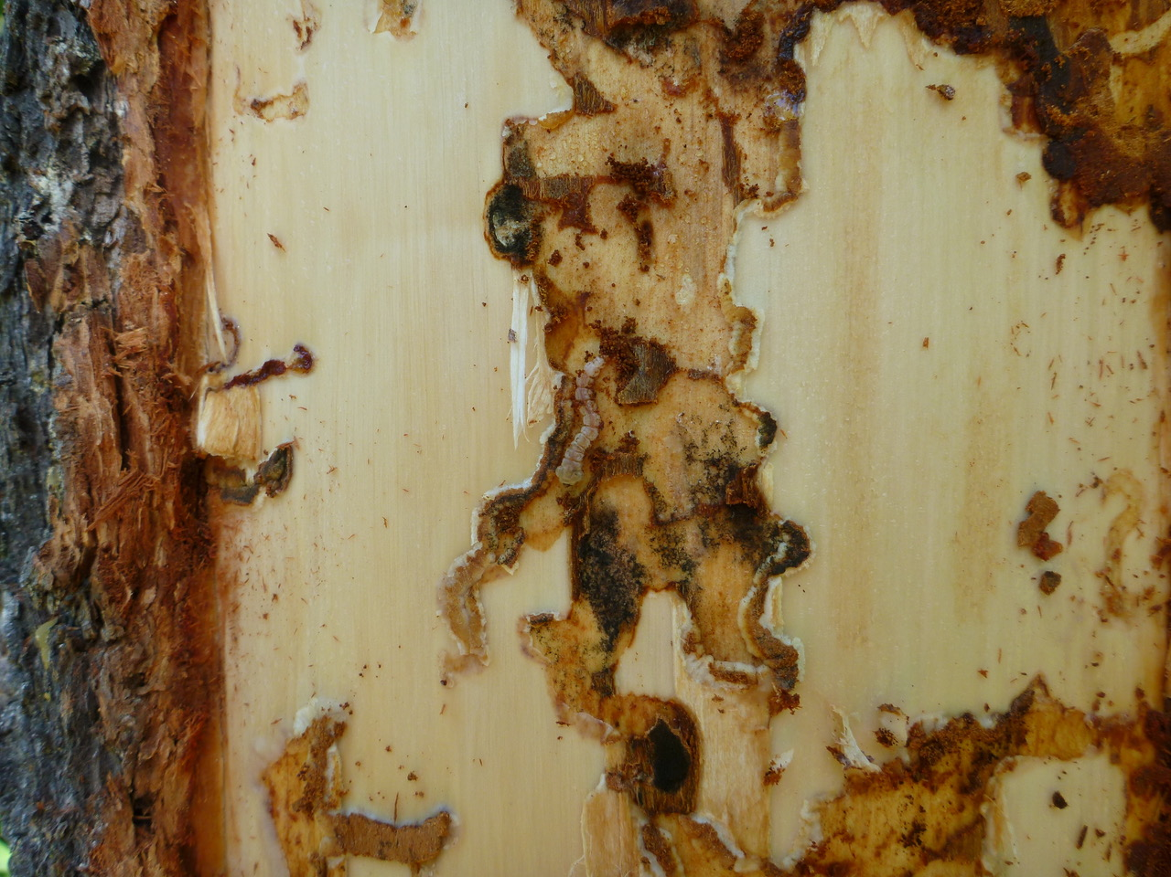

**Figure 6.** DF stem with FFB galleries begin as pencil-thin lines eaten through the cambium layer and getting bigger as larvae feed on the phloem. Notice that FFB eat very little of the phloem, a.) thin pencil line early instar galleries leading into thicker bloblike galleries of older larvae; b.) FFB galleries of older larvae through phloem; c.) late instar FFB; and d.) FFB late instar larvae inside gallery feeding on phloem (blue arrow).

**Black Phloem**

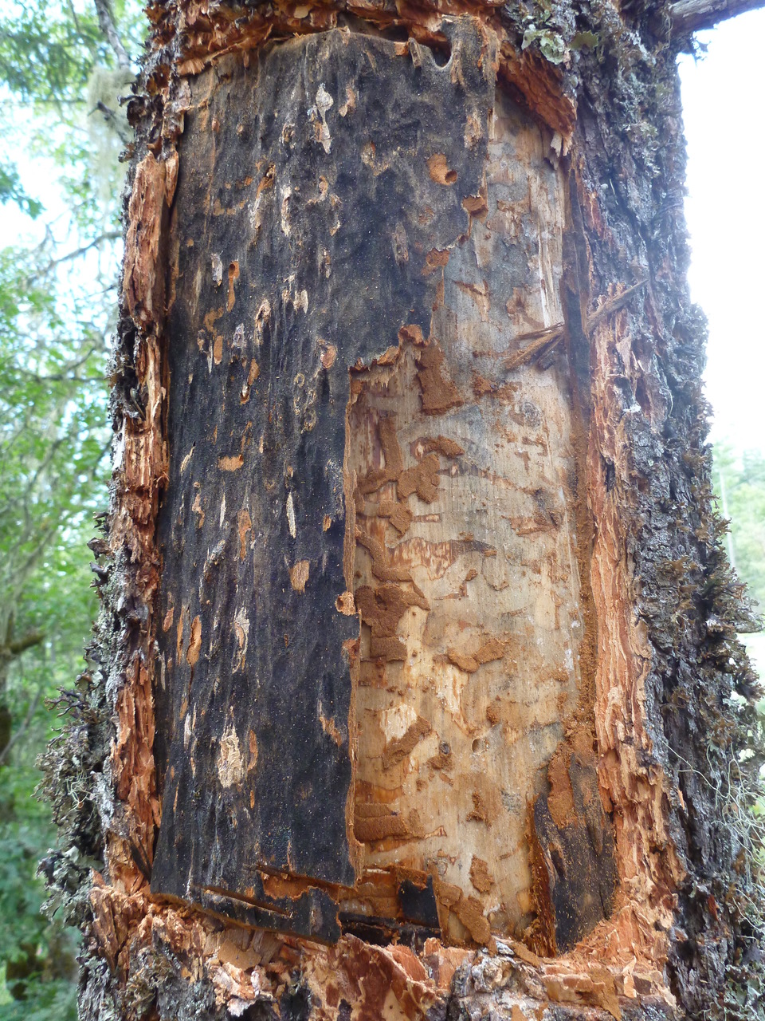

**Figure 7.** DF phloem turns black and get hard and peels off like a book where FFB have fed. Observations of black phloem under the bark is diagnostic of an FFB infestation.

**Case studies showing application of the ratings**

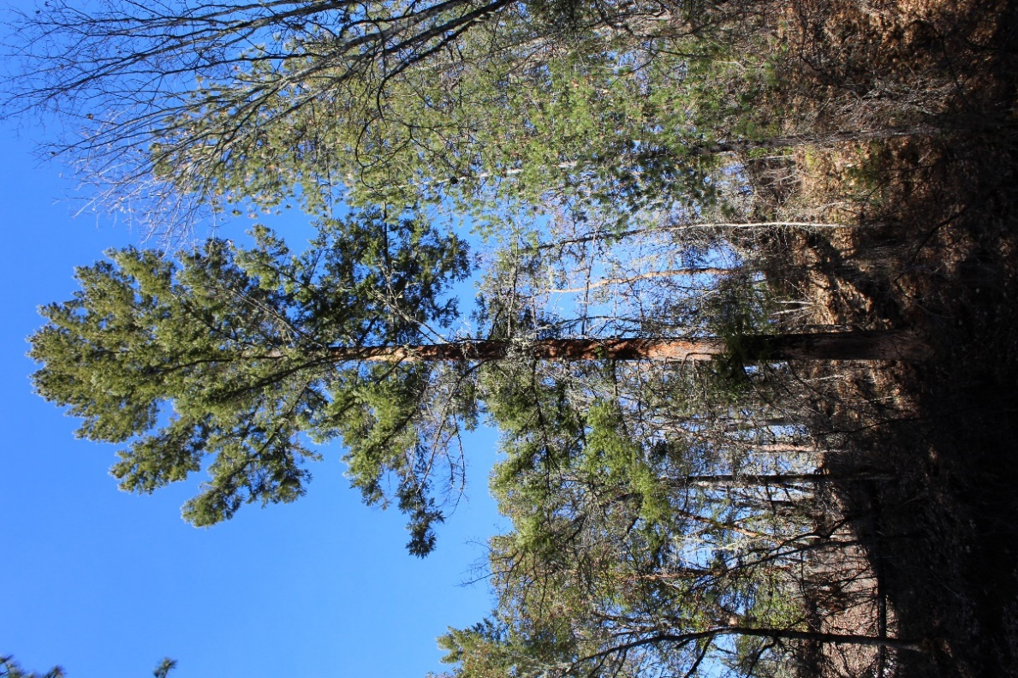

**Figure 8.** This DF died within a few months after the photo was taken. Note the woodpecker shaving on the bole, indicative of FFB infestation. Although the foliage color and crown density are fair, the rounded crown indicates very poor recent height growth and there is branch dieback on the lower crown, likely unrelated to shading, giving it a crown decline rating of at least 1.  Despite being located at the edge of a riparian zone, we rated the site as high risk due to high local beetle pressure, close proximity (~100') to both a stand edge and an oak woodland, and moderate heat load, for a total site score of 9. Adding the crown decline rating of 1 and site rating of 9 result in an individual tree rating of 10, at the top end of the "moderate" category. Trees with this rating have a 10-50% risk of mortality within three years. At the landscape scale, this site is rated as high risk, with a mean annual precipitation of around 30 inches and an elevation under 2,000 feet. This example illustrates how trees located in an area of high landscape risk and on high-risk sites are very susceptible to FFB infestation, even if individual trees appear relatively healthy.

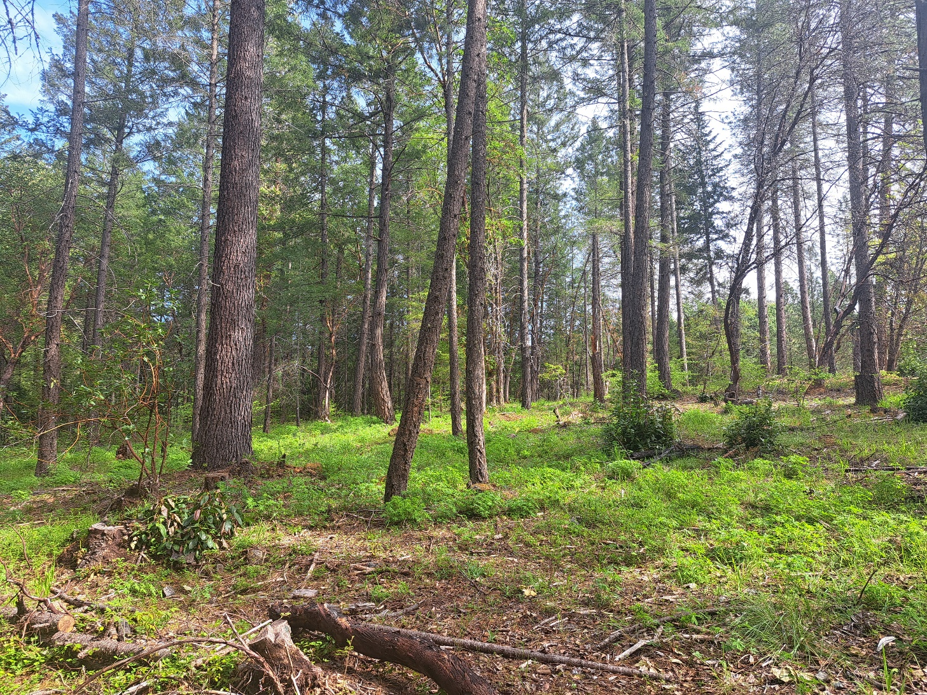

**Figure 9.** Thinning has the potential to reduce local beetle population pressure, at least temporarily. This stand was thinned in summer 2023. Prior to thinning site-level beetle population pressure was high, giving the site a beetle population level score of 6. Following a thinning that removed most or all of the recently killed and dying (infested) trees, beetle pressure was probably significantly reduced. However, there were still infested trees within ¼ mile, and we would score this individual site as a 3.

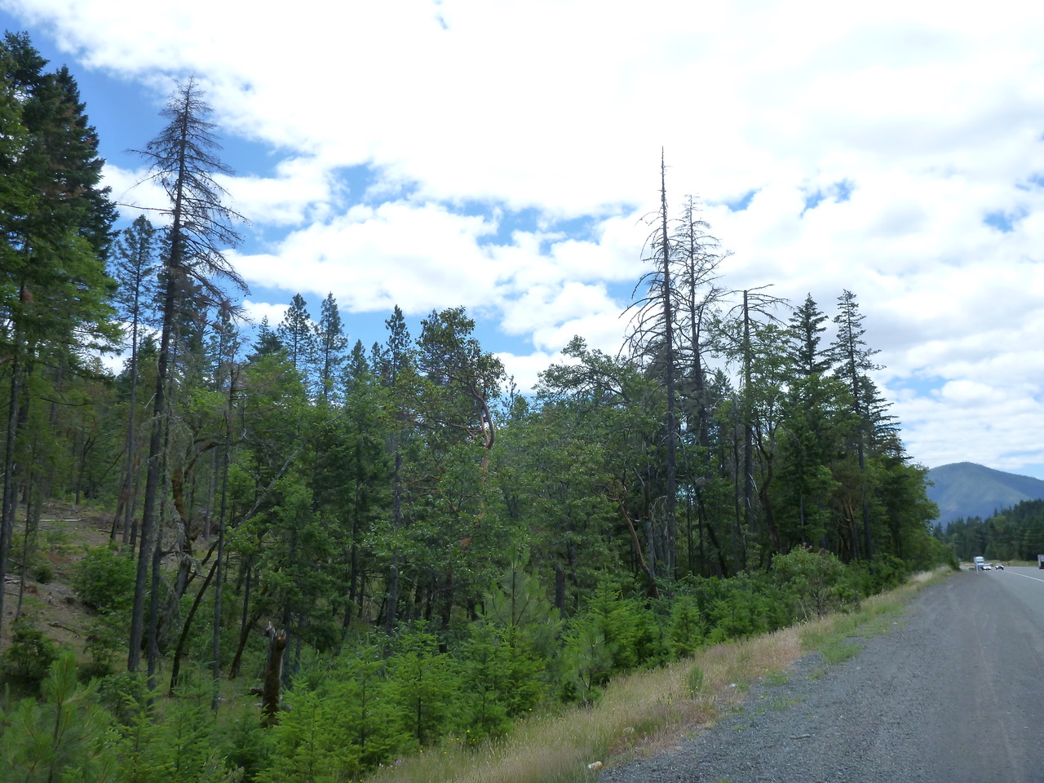

**Figure 10.** Hayes Hill, BLM. (Want to add anything as to why this photo is here?)

**Appendix B. Methods and Monitoring Data and Results**

The landscape, site, and individual tree ratings were developed with data from remote sensing and field plots, as well as field observations by the authors and other local professionals. Specific data sources, methods, and results for each rating level are discussed below. We stress that while overall patterns of, and trends in DF decline and mortality in SW Oregon are relatively well understood and supported with many years of Aerial Detection Survey and climate data, the ratings themselves are preliminary and will likely be updated as field plot data accumulates over the next few years.

**Data sources**

* USFS/ODF aerial detection survey, 2000-2024. Provides annual maps of insect and disease detections and estimated damage levels.
* PRISM Climate Group, Oregon State University, <https://prism.oregonstate.edu.> Provides 30-year normals for precipitation, vapor pressure deficit, temperature and other climatic variables.
* Climatic Water Deficit. Climatic water deficit is a modeled estimate of moisture stress that integrates precipitation, temperature, and soil water storage; CWD is the potential evapotranspiration minus actual evapotranspiration, in millimeters. The CWD data used in the Bennett et al. paper referenced below was updated in 2024. The newest estimates are used in the landscape risk rating described below.
* Plot data. To monitor DF decline and mortality in SW Oregon and to evaluate the risk rating systems described in this document, the Forest Health Protection (FHP) program installed 492 field plots in the summers of 2023 and 2024 (figure 1). The plots were distributed across a wide range of sites in SW Oregon ranging from hot and dry to cool and wet, from the Applegate to the North Umpqua watersheds, on Forest Service and BLM lands.

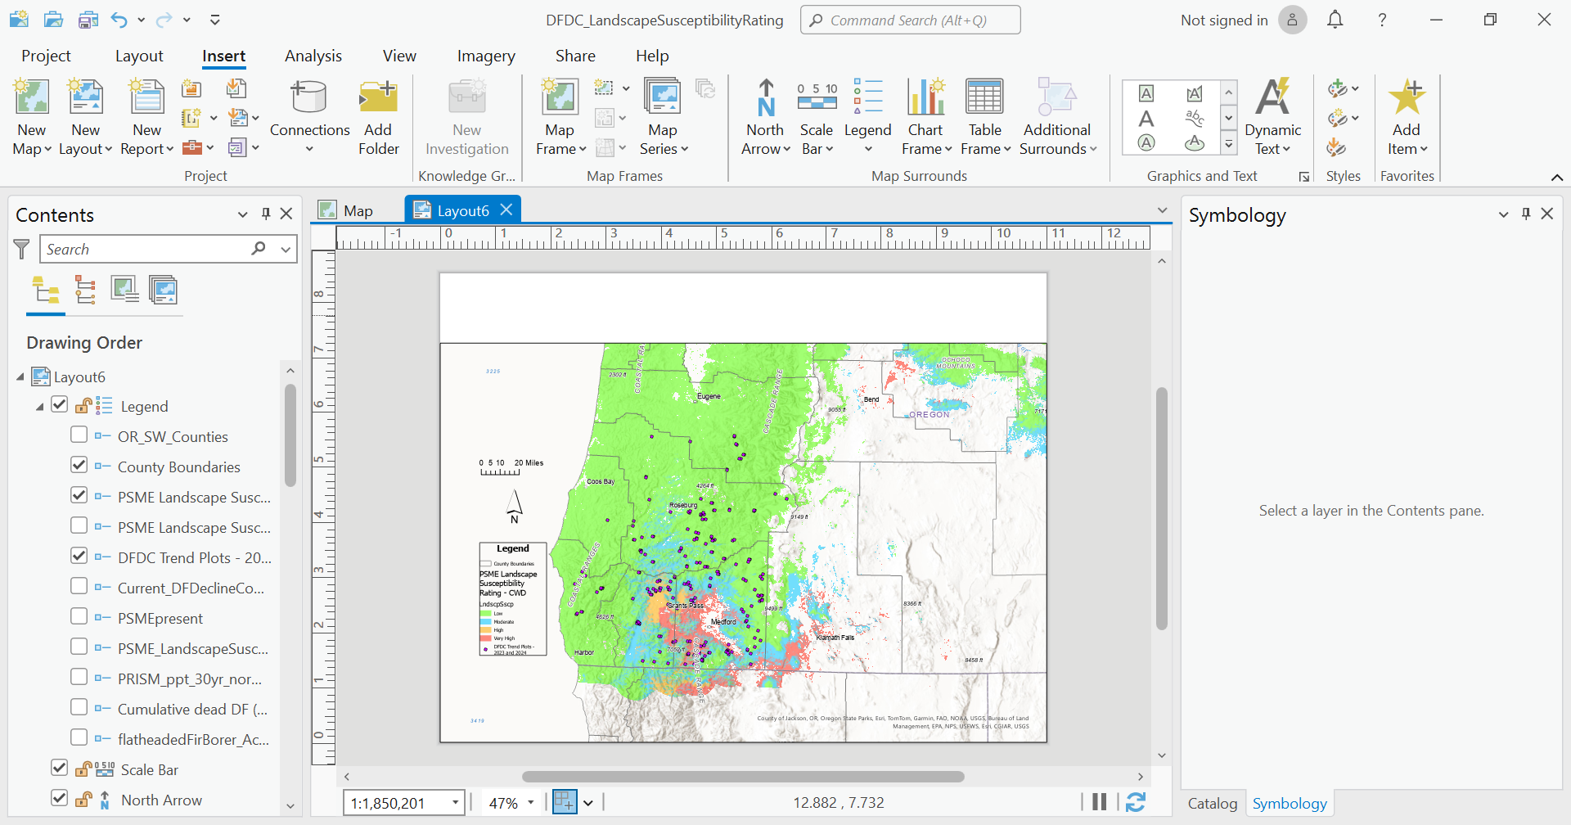

**Figure 1**. Sites sampled in 2023 and 2024.

* This landscape was stratified by climatic water deficit and years since recent mechanical treatment as pulled from USFS and BLM datasets. A roughly equal number of plots were assigned to each of 12 levels of CWD-treatment combinations, from very low to very high CWD, as well as no treatment, 1-10 years ago and 11-25 years ago. Plot centers were then randomly located within stands that were accessible, at least 65 feet from the edge of the stand boundary, and at least 264 feet apart (4 chains). To be included, each plot had to have at least three live DF greater than 8” DBH; therefore, initial plot locations that didn’t meet this criterion were moved by walking another chain (66 feet) in a randomly generated direction and continuing until criteria was met within the stand. Three plots per stand were installed. Importantly, by design, this sampling scheme excluded patches of DF mortality where there were few if any live trees. The intent was to monitor live trees rather than characterize mortality levels per se.

At each plot center, a variable radius plot was established using a 20 or 40 BAF prism, depending on tree size and six to eight “in” trees. Species and DBH were recorded for all trees greater than 8” DBH, and a crown decline rating was given for each live DF. Any DF mortality within a one-acre circular plot around the plot center (radium approximately 120’) was evaluated to determine if it was killed by the FFB within the past year, using the methods described above. Ratings for the topo factor, edge, and soils were noted and combined with the beetle population level to determine the stand risk rating. Also noted was the plant association and any observations about the site or trees. A total of 2,843 trees were measured and rated across 492 plots.

* Individual tree monitoring plots. To evaluate the individual tree risk rating system, we monitored 44 trees distributed across six sites over 2.5 years (three growing seasons). All six sites fell in the landscape high risk category based on precipitation. At each site we selected individual trees representing varying levels of vigor and decline. We rated beetle pressure and site characteristics to determine a site-level risk rating, with four of the stands falling in the high site risk category and two in the moderate category. We then rated crown decline for each selected tree and added that to the site risk rating to determine the individual tree risk rating. Following the May 2024 monitoring visit, the Salt Creek plot burned in a wildfire, and data from this site were not used to develop the risk rating. In spring 2023, we added nine trees at another site (Tolman Creek), and monitored these trees two years later in March 2025. Characteristics of the seven sites are shown below.

|  |  |  |  |  |  |  |
| --- | --- | --- | --- | --- | --- | --- |
| **Site** | **Elevation** | **Mean annual precip.** | **Site Susceptibility Rating** | **# of trees in plot May 2022**  **(spring 2023 Tolman Creek)** | **# of trees alive May 2024 (March 2025 Tolman Creek)** | **# of trees dead May 2024 (March 2025 Tolman Creek)** |
| 4 Corners | 4,300' | 25" | Mod | 7 | 7 | 0 |
| Salt Creek | 3,100' | 32" | High | 6 | 5 | 1 |
| Boaz | 1,750' | 24" | High | 5 | 1 | 4 |
| Jacksonville | 1,750' | 22" | High | 6 | 4 | 2 |
| Pilot Joe | 1,900' | 25" | Mod | 8 | 8 | 0 |
| Collins | 1,800' | 26" | High | 11 | 8 | 3 |
| Tolman Creek | 3,200 | 23” | High | 9 | 9 | 0 |

**Results - Landscape susceptibility rating**

The relationship between FFB detections in SW Oregon from 2000-2019, estimated population and damage levels, and climate variables such as mean annual precipitation, climatic water deficit, maximum summer temperatures, and vapor pressure deficit (VPD) is described in Bennett et al. 2023. In a nutshell, this study suggested that cumulative FFB detections during this time period were higher following drought and in hot, dry locations in interior SW Oregon. The number of trees killed/acre over that time period was more than 60 times greater in 1 km grid cells with a mean annual precipitation under 35” compared to grid cells averaging over 60”. These precipitation levels were associated with marked increases and decreases, respectively, in FFB mortality and therefore were used as thresholds between low, moderate, and high landscape risk.

The following two tables show relevant characteristics from the 492 field plots in relation to mean annual precipitation and climatic water deficit.

|  |  |  |  |  |  |  |  |  |  |
| --- | --- | --- | --- | --- | --- | --- | --- | --- | --- |
| **Precipitation category** | **Plot count** | **Percent of plots that are high risk** | **Mean beetle pressure**  **(0-6)** | **Mean crown decline (0-3)** | **% High ITR** | **% Mod ITR** | **% Low ITR** | **Percent of plots with DF mortality** | **In plots with DF mortality, % of DF BA that is dead** |
| **1 (<25")** | 8 | 75% | 4.9 | 1.2 | 8% | 67% | 25% | 13% | 20% |
| **2 (25-35")** | 88 | 50% | 3.8 | 1.3 | 8% | 38% | 54% | 31% | 31% |
| **3 (35-45")** | 128 | 48% | 3.0 | 1.3 | 5% | 30% | 65% | 10% | 23% |
| **4 (45-60")** | 156 | 38% | 2.3 | 1.3 | 4% | 24% | 72% | 6% | 19% |
| **5 (>60")** | 112 | 28% | 2.1 | 1.2 | 3% | 20% | 77% | 19% | 18% |

Percent of plots that are high risk refers to the percent of plots in that precipitation category that were rated as high risk (score of 6 or above). Mean beetle pressure refers to the average beetle pressure rating among plots in that precipitation category, and so on for mean crown decline. The % ITR columns refer to the percent of trees in each precipitation class falling into the high, moderate, and low individual tree risk categories.

|  |  |  |  |  |  |  |  |  |  |
| --- | --- | --- | --- | --- | --- | --- | --- | --- | --- |
| **Climatic Water Deficit (mm) category** | **Plot count** | **Percent of plots that are high risk** | **Mean beetle pressure** | **Mean crown decline** | **% High ITR** | **% Mod ITR** | **% Low ITR** | **Percent of plots with DF mortality** | **In plots with DF mortality, % of DF BA that is dead** |
| **5 (250-300mm)** | 60 | 58% | 4.1 | 1.3 | 7% | 48% | 44% | 28% | 31% |
| **4 (200-250mm)** | 126 | 48% | 3.3 | 1.3 | 8% | 26% | 66% | 14% | 21% |
| **3 (150-200mm)** | 178 | 38% | 2.4 | 1.3 | 2% | 25% | 72% | 11% | 24% |
| **2 (100-150mm)** | 110 | 30% | 2.1 | 1.3 | 2% | 24% | 74% | 13% | 21% |
| **1 (<100mm)** | 18 | 33% | 2.3 | 1.3 | 8% | 25% | 67% | 17% | 17% |

In general, these data suggest that plots located in areas of high landscape susceptibility (low precipitation and/or high climatic water deficit) are more likely to be rated as high susceptibility, have higher levels of beetle pressure, more individual trees in the high and moderate susceptibility categories, and are more likely to have DF mortality.

The 3-5 year probability of mortality is discussed in table 1 and refers to the likelihood of encountering mortality at a randomly located site or plot within the susceptibility rating within the next 3-5 years. This number is based roughly on the percentage of highly susceptible plots found within each zone from the 2023-4 FHP trend plot data. The estimated 3-5 year basal area loss is based on the following:

* Low end of the range is the average percentage of highly susceptible trees found in the zone, from the ADS plot data. The low end of the range assumes that only highly susceptible trees die within the next 5 years.
* The high end of the range is the percentage of high AND moderate susceptible trees found in the zone. The high end of the range assumes all highly susceptible and all moderately susceptible trees die within the next 5 years.

**Results - Site susceptibility rating**

The following table shows relevant characteristics from the 492 field plots in relation to the site risk rating.

|  |  |  |  |  |  |  |  |  |  |
| --- | --- | --- | --- | --- | --- | --- | --- | --- | --- |
| **Plot risk category** | **Plot count** | **Percent of plots in high landscape risk category** | **Mean beetle pressure** | **Mean crown decline** | **% High ITR** | **% Mod ITR** | **% Low ITR** | **Percent of plots with DF mortality** | **In plots with DF mortality, % of DF BA that is dead** |
| **High** | 202 | 25% | 5.1 | 1.4 | 11% | 66% | 23% | 18% | 29% |
| **Mod** | 105 | 28% | 3.0 | 1.3 | 0% | 3% | 96% | 14% | 16% |
| **Low** | 185 | 9% | 0.0 | 1.2 | 0% | 0% | 100% | 11% | 22% |

These data suggest that high susceptibility plots have much higher percentages of individual trees in the moderate to high-susceptible categories, and this is largely attributable to higher beetle pressure at the sites, since the mean crown decline differs little across plot risk categories. Somewhat surprisingly, the percent of plots in the high-susceptibility landscape category differs little between the high and moderate plot susceptibility categories, and the percent of plots with mortality in these two categories is also similar.

**Results - Individual tree susceptibility rating**

The following table shows summary results from the individual tree ratings after two years (May 2024) and after three growing seasons (December 2024). As noted above, the December 2024 dataset is smaller due to the loss of one site to wildfire.

|  |  |  |  |  |  |  |  |  |  |  |
| --- | --- | --- | --- | --- | --- | --- | --- | --- | --- | --- |
|  |  | **May 2022 ratings using revised individual tree risk score (plot risk score + CD)** | | | | | | | | |
| **2-yr status (5/24)** | | **4** | **5** | **6** | **7** | **8** | **9** | **10** | **11** | **12** |
|  | **# trees/alive** | 2 | 5 | 7 | 1 | 3 | 10 | 5 | 0 | 1 |
|  | **# trees/dead** | 0 | 0 | 0 | 0 | 1 | 1 | 2 | 2 | 4 |
|  |  | **May 2022 ratings using revised individual tree risk score (plot risk score + CD)** | | | | | | | | |
| **3-yr status (12/24)** | | **4** | **5** | **6** | **7** | **8** | **9** | **10** | **11** | **12** |
|  | **# trees/alive** | 2 | 6 | 5 | 1 | 3 | 6 | 4 | 0 | 1 |
|  | **# trees/dead** | 0 | 0 | 0 | 0 | 1 | 0 | 2 | 2 | 4 |

*Includes 9 trees at Tolman Creek site

Individual tree susceptibility category Trees alive 12/24 Trees dead 12/24

Low (0-7) 14 0

Moderate (8-10) 22* 3

High (11-13) 1 6

These data suggest a logical grouping for the low, moderate, and high-risk individual tree ratings based on the numbers of observed live and dead trees in each category. Note that an individual tree rating of 13 is possible, but none of the trees in our sample had that rating.

Given the probability of additional mortality among the trees in this relatively small dataset over the next few years, it’s likely that the thresholds for each risk category will have to be adjusted.

**Appendix C: Tatum guide for Douglas-fir decline complex**

|  |  |  |  |
| --- | --- | --- | --- |
| **Landscape Susceptibility Rating** | | | |
| **Landscape Susceptibility Category** | **Mean annual precip. / Mean annual CWD** | **3-5 year probability of mortality** | **3-5 year estimated DF BA loss** |
| **Very high**  DF mortality very abundant & intensifying | <35” AND  >250mm | >75% | 15%-80%+ |
| **High**  DF mortality abundant & intensifying | <35” OR  >350mm | 50%-75% | 10%-50% |
| **Moderate**  DF decline & mortality common during events, especially on harsh sites (e.g., margins of oak woodlands) | 35”-45” AND/OR  200mm-250mm | 25%-50% | 5%-35% |
| **Low**  DF decline complex is uncommon but can occur at low levels in association with harsh site conditions | >45” AND/OR  <200mm | <25% | 0%-25% |

|  |  |  |
| --- | --- | --- |
| **Site Susceptibility Rating** | | |
| **Factor** | | **Points** |
| **Local beetle population pressure** | | |
| DF mortality from FFB found within 1-acre plot (120’ radius) | | 6 |
| DF mortality from FFB found within ¼ mile | | 3 |
| DF mortality from FFB not found within ¼ mile | | 0 |
|  | | |
| **Topographic factor (heat load)** | | |
| Southerly aspects, typically SW, frequently in combination with one or more of the following: >35% slopes, ridges & upper slope positions, convex terrain | | 2 |
| All others | | 1 |
| NE aspects, typically in combination with concave terrain | | 0 |
|  | | |
| **Proximity to stand edge** | | |
| Stand edge is within 100’ | | 1 |
| Stand interior | | 0 |
|  | | |
| **Soil factor** | | |
| Soil moisture availability is severely limited due to shallow depth, high clay content, and/or other factors. The presence of Oregon white oak is often an indicator of these conditions. | | 1 |
| All others | | 0 |
|  | | |
| **Site Susceptibility Category and Loss Prediction** | **Total Points** | |
| ***High*** –   * Significant DF mortality (10-100% of trees) is likely to occur within 3-5 years; recent DF mortality is often present; * ≥10% of individual DF in high sites classified as high for the individual tree rating, meaning they have >50% probability of mortality within 3 years; * ~20% of these sites have recent DF mortality with ≥ 30% of DF basal area recently killed | | ≥ 6 |
| ***Moderate –***  Some DF mortality may occur within 3-5 years; recent mortality may be present | | 4-5 |
| ***Low –***  DF mortality is unlikely to occur within 5 years | | 0-3 |

|  |  |  |
| --- | --- | --- |
| **Individual Tree Susceptibility Rating** | | |
| **Factor** | | **Points** |
| **Site susceptibility rating** (see Site Susceptibility Rating) | | 0-10 |
|  | | |
| **Crown decline rating** | | |
| Severe recent crown decline | | 3 |
| Moderate recent crown decline | | 2 |
| Light recent crown decline | | 1 |
| No recent crown decline | | 0 |
|  | | |
| **Total points** | | 0-13 |
|  | | |
| **Category and Loss Prediction** | **Number of Points** | |
| ***High*** (>50% probability of mortality in 3 years) | | 11-13 |
| ***Moderate*** (10-50% probability of mortality in 3 years) | | 8-10 |
| ***Low*** (<10% probability of mortality in 3 years) | | 0-7 |